**YARD DUTY AND SUPERVISION POLICY**

**Help for non-English speakers**

If you need help to understand the information in this policy, please contact Rosehill Secondary College on 9337 2488.

**Purpose**

To ensure school staff understand their supervision and yard duty responsibilities.

**Scope**

This policy applies to all teaching and non-teaching staff at Rosehill Secondary College, including education support staff, casual relief teachers and visiting teachers.

**Policy**

Appropriate supervision is an important strategy to monitor student behaviour and enables staff to identify and respond to possible risks at school as they arise. It also plays a vital role in helping schools to discharge their duty of care to students.

The Principal is responsible for ensuring that there is a well organised and responsive system of supervision and yard duty in place during school hours, before and after school, and on school excursions and camps and other school activities.

School staff are responsible for following reasonable and lawful instructions from the Principal, including instructions to provide supervision to students at specific dates, times and places. Supervision should be undertaken in a way that identifies and mitigates risks to child safety.

## Before and after school

Rosehill Secondary College’s grounds are supervised by school staff from 8:30am until 3:45pm. Outside of these hours, school staff will not be available to supervise students.

## Yard duty

All staff at Rosehill Secondary College are expected to assist with yard duty supervision and will be included in the weekly roster.

The Daily Organiser is responsible for preparing and communicating the yard duty roster on a regular basis. At Rosehill Secondary College, school staff will be designated a specific yard duty area to supervise.

**Yard duty zones**

The designated yard duty areas for our school as at Term 2, 2022 are:

|  |  |  |  |
| --- | --- | --- | --- |
| **Duty Area** | **Area Description** | **Out of Bounds** | **Duty Times** |
| A/B Wing | Move through the Year 7 Area, between A & B wing and between B & C wing. Lock exit doors to South and East accessing the canteen from B-wing unless it is wet day weather. Bolt the door by the Art rooms. Students must walk around the western end of B-wing to access the canteen. Corridors should always remain clear.  BS – walk around with the emphasis on locker bays and prompting students to put phones away before school starts. | Car Park off sapphire street  Students should not be in the corridors | BS, R, L1, L2 |
| Basketball Courts | Spend your time circulating the outdoor Basketball courts. Only basketball and downball are allowed in this area. Ensure you walk around the back of D-wing. The third basketball court is for female use only. | No kicking ball games allowed.  Between fence and backyards | R, L1, L2 |
| Bus Duty In | Assist with loading of students catching buses inside the school. Students line up at designated bus spots between B & C wings. They receive a coloured popsicle stick to gain entry to the bus. A separate staff will be at the entrance of the designated bus checking and collecting the popsicle stick with the correct colour.  All staff must remind students to touch on with their myki pass, wear a mask and fill the space from the back first. |  | AS |
| Bus Duty Out | Assist with loading of students catching buses from the Albert St bus stop.  All staff must remind students to touch on with their myki pass, wear a mask and fill the space from the back first. |  | AS |
| Canteen | Arrive as soon as possible to ensure students are in one row and that students access the counter one at a time, or when canteen staff call students forward. Ensure students are in a line and limit congestion. If needed the line can extend along the outside of the canteen towards P3 and P4. Ensure that the exit is always clear and that when students finish the leave around the other side of the canteen. | In the gardens, in the class windows | R, L1 |
| C/D Wing | Move around the area between C & D wings |  | R, L1, L2 |
| Library | Only used as required eg. Wet weather, exams.  No hats, bags or eating in the library. For any additional advice ask the library staff. |  |  |
| Portables/ Gym/ Music | The area from P5 to P23, including outside the Gym, ECA, VCE centres and Music room. Ball games are allowed on the corners of concrete areas, but not in front of the music building or around the stairs. Watch for smokers behind the gym, by P21 – 23 around the stairwell. | Inside portables | R, L1, L2 |
| Oval | Circulate around the oval, along Albert Street, and by the cricket courts. Kicking ball games allowed. Watch that students don’t throw things into backyards. Students should be 5 meters from gutters. Student at cricket nets should no be using hard balls unless all students are padded and wearing helmets. | Past the speed bump, between fence and roadway, | R, L1, L2 |
| **Duty Times Codes & Times:** BS (Before School) 8:30 – 8:55, R (Recess) 11:30 – 11:55, L1 (Lunch 1) 1:15 – 1:40, L2 (Lunch 2) 1:35 – 2:00, AS (After School) 3:15 – 3:45 | | | |

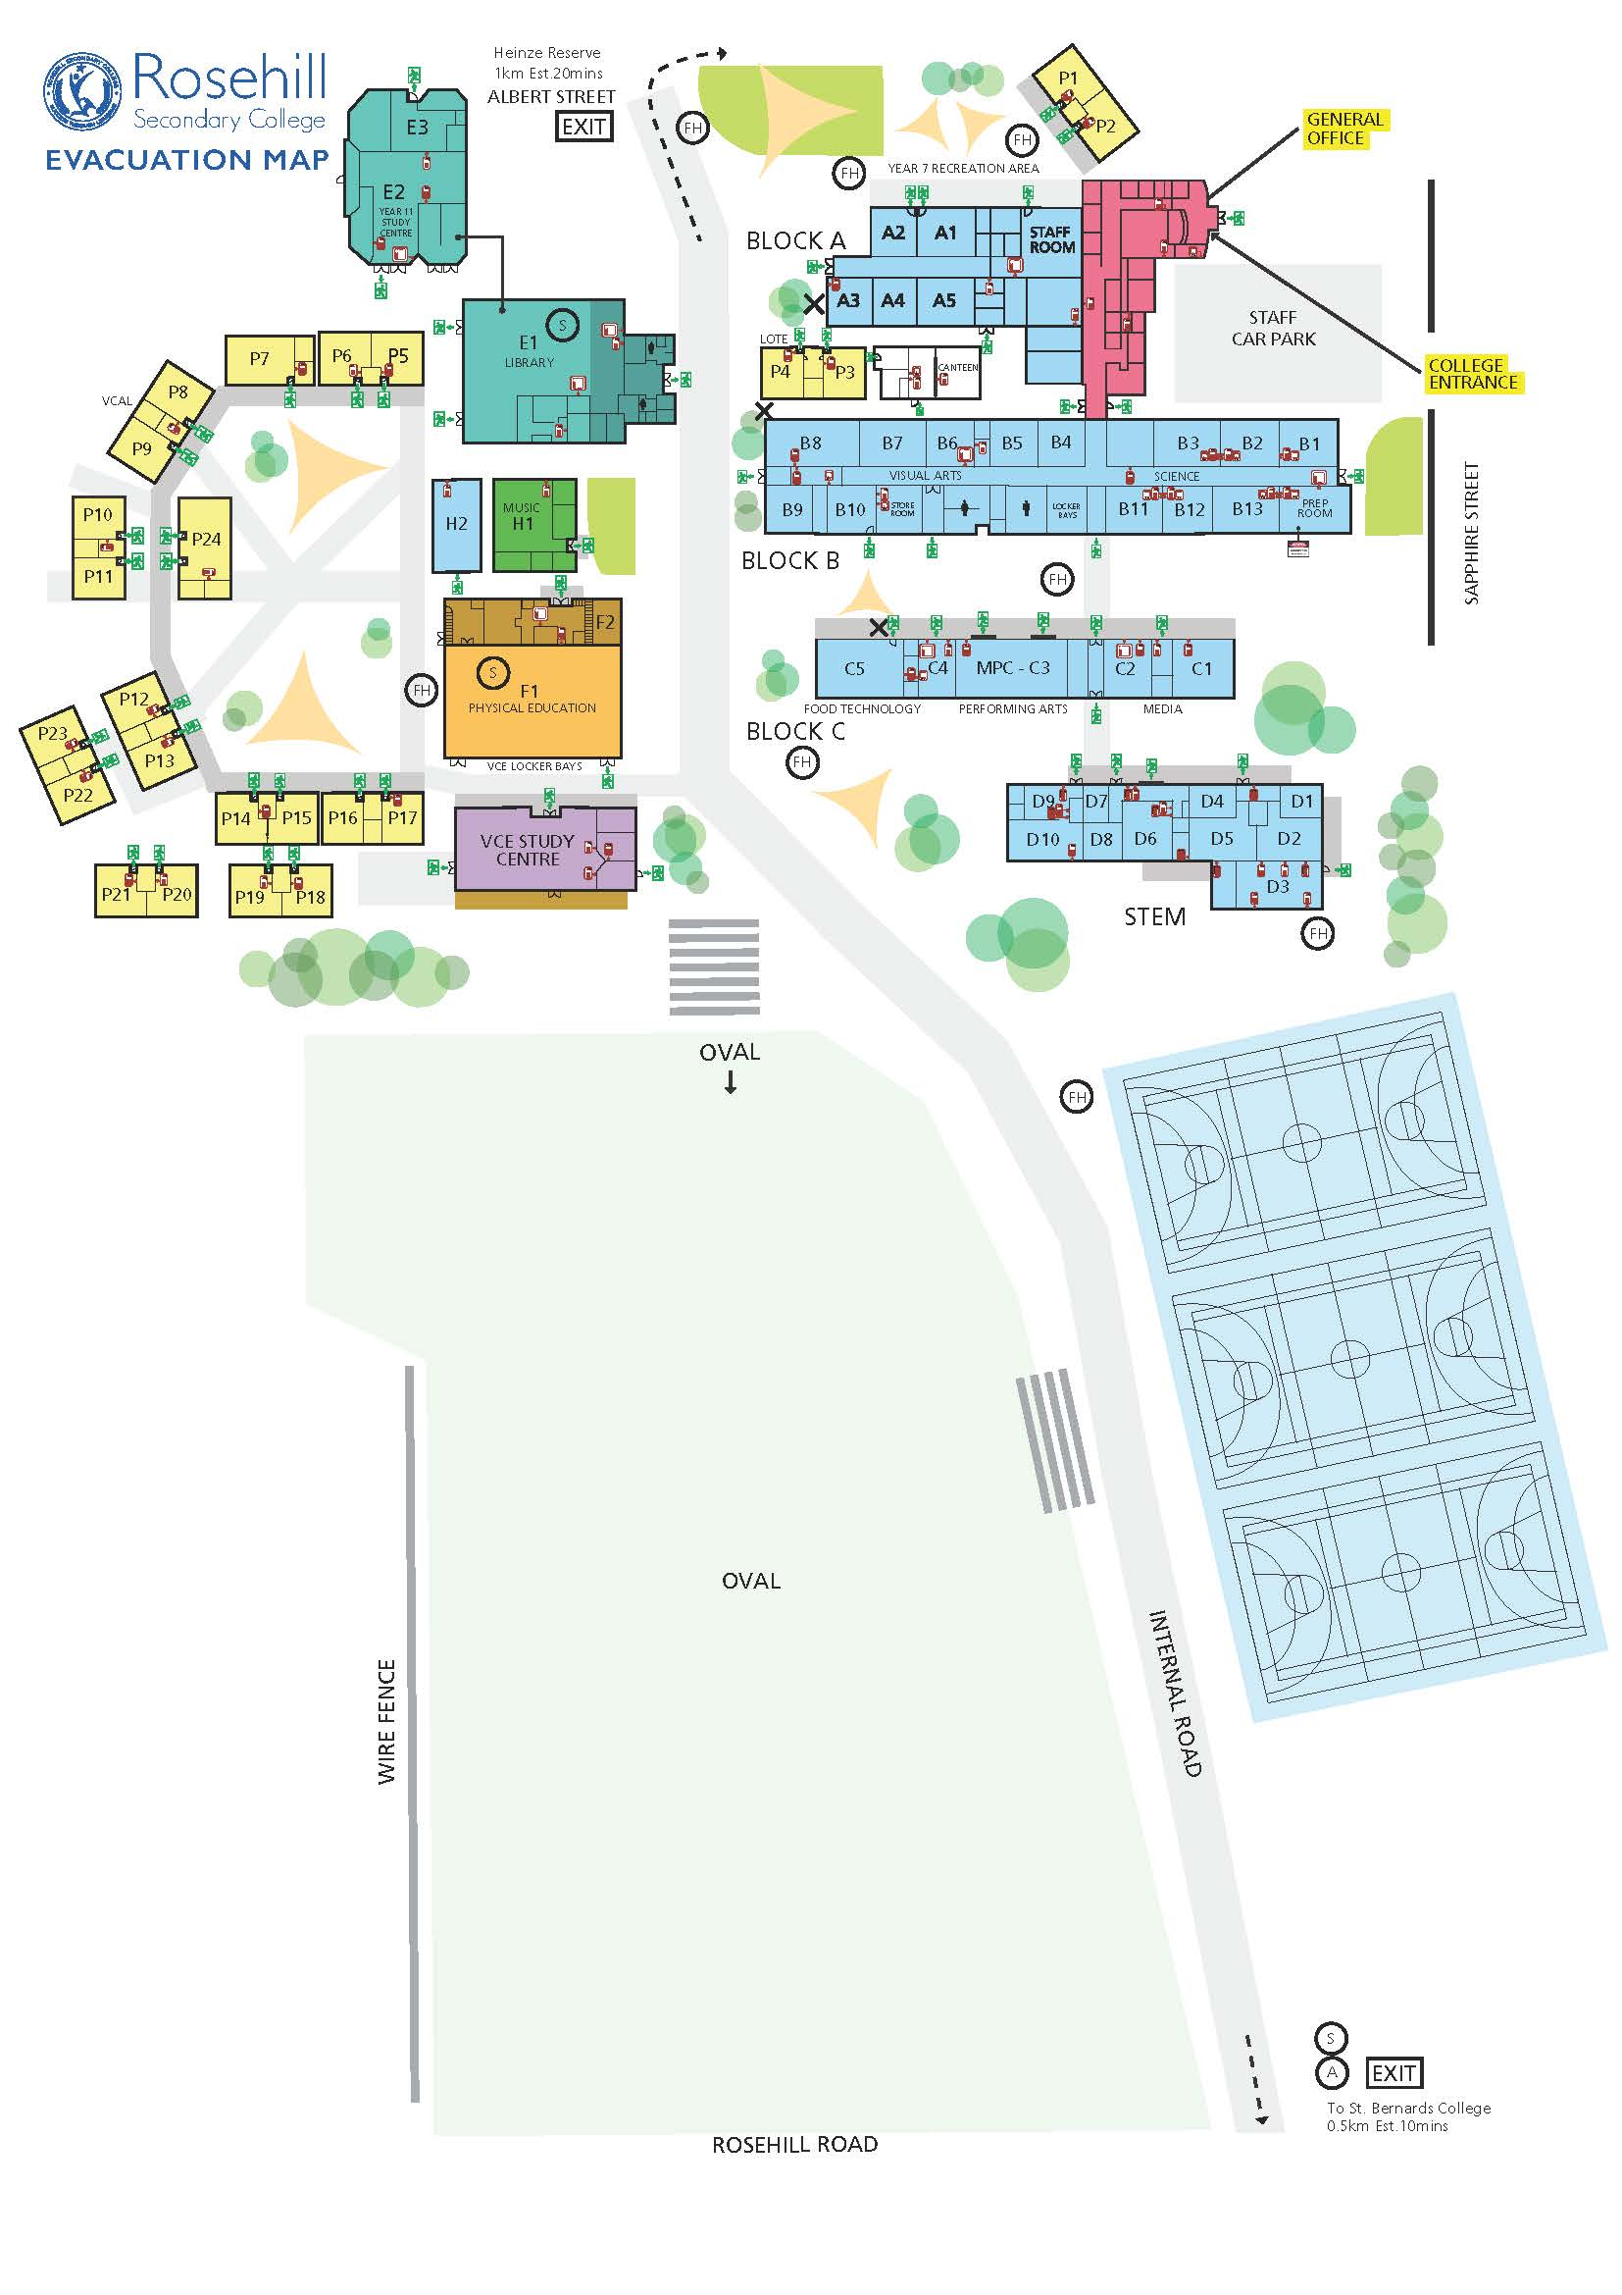

Canteen

Road next to Oval

Bus Duty In

Bus Duty Out

Legend

B Wing Courtyard

Basketball Courts

Bus Duty In/Out

C/D Wing

Canteen

Portables/Gym/Music

Road next to Oval

Year 7 Area

**Yard duty equipment**

School staff must:

* wear a provided safety/hi-vis vest whilst on yard duty. Each staff member has their own safety vest.
* always carry the yard duty bum bag during supervision. The yard duty bum bags are stored in every staff room.
* be familiar with the yard duty information pack containing student health and safety information for anaphylactic students.
* carry your mobile phone with you when on duty in case of emergency

**Yard duty responsibilities**

Staff who are rostered for yard duty must remain in the designated area until they are replaced by a relieving staff member.

During yard duty, supervising school staff must:

* know the location of your duties and arrive on time
* methodically move around the designated zone ensuring active supervision of all students
* where safe to do so, approach any unknown visitor who is observed on school grounds without a clear legitimate purpose, and ensure they have a visitor pass and have signed in (excluding drop off and collection periods).
* ensure students from Year 8 to 12 are not in the Year 7 area.
* be alert and vigilant
* intervene immediately if potentially dangerous or inappropriate behaviour is observed in the yard
* enforce behavioural standards and implement appropriate consequences for breaches of safety rules, in accordance with any relevant disciplinary measures set out in the school’s Code of Conduct policy. Watch for… bullying, harassment, unduly rough play, littering, students in room unsupervised, use of illegal substances, students out of bounds, inappropriate signs of affection, students climbing onto buildings or benches, students out of uniform and students affected by illness.
* ensure that students who require first aid assistance receive it as soon as practicable
* log any incidents or near misses as appropriate on Compass.

If being relieved of their yard duty shift by another staff member (for example, where the shift is ‘split’ into 2 consecutive time periods), the staff member must ensure that a brief but adequate verbal ‘handover’ is given to the relieving staff member in relation to any issues which may have arisen during the first shift.

If the supervising staff member is unable to conduct yard duty at the designated time, they shouldcontact the Daily Organiserwith as much notice as possible prior to the relevant yard duty shift to ensure that alternative arrangements are made.

If the supervising staff member needs to leave yard duty during the allocated time, they should contact the general office, Daily Organiser or Principal team memberbut should not leave the designated area until the relieving staff member has arrived in the designated area.

If the relieving staff member does not arrive for yard duty, the staff member currently on duty should contact the office, Daily Organiser or a Principal team member and not leave the designated area until a relieving staff member has arrived.

Students will be encouraged to speak to the supervising yard duty staff member if they require assistance during recess or lunchtime.

## Classroom

The classroom teacher is responsible for the supervision of all students in their care during class.

If a child is asked to leave the classroom. It must be in accordance with Rosehill’s disciplinary procedures.

If a teacher needs to leave the classroom unattended at any time during a lesson, they should first contact the office, Daily Organiser, or a Principal team member for assistance. The teacher should then wait until a replacement staff member has arrived at the classroom before leaving.

## School activities, camps and excursions

The Principal and leadership team are responsible for ensuring that students are appropriately supervised during all school activities, camps and excursions, including when external providers are engaged to conduct part or all of the activity. Appropriate supervision will be planned for school activities, camps and excursions on an individual basis, depending on the activities to be undertaken and the level of potential risk involved, and will follow the supervision requirements in the Department of Education and Training [Excursions Policy](https://www2.education.vic.gov.au/pal/excursions/policy).

## Digital devices and virtual classroom

Rosehill Secondary College follows the Department’s [Cybersafety and Responsible Use of Technologies Policy](https://www2.education.vic.gov.au/pal/cybersafety/policy) with respect to supervision of students using digital devices.

Rosehill Secondary College will also ensure appropriate supervision of students participating in remote and flexible learning environments while on school site. In these cases, students will be supervised in their designated learning space.

While parents are responsible for the appropriate supervision of students accessing virtual classrooms from home:

* student attendance will be monitored in every class via Compass. On an asynchronous day the roll will be taken at the beginning of the day.
* any wellbeing or safety concerns for the student will be managed in accordance with our Child safety and Wellbeing Policy.

## Students requiring additional supervision support

Sometimes students will require additional supervision, such as students with disability or other additional needs. In these cases, the Principal or delegate will ensure arrangements are made to roster additional staff as required. This may include on yard duty, in the classroom or during school activities.

## Workplace learning programs

When students are participating in workplace learning programs, such as work experience, school-based apprenticeships and traineeships, and structured workplace learning, the safety and welfare of the student is paramount. Organising staff are required to follow all applicable Department of Education and Training policies and guidelines in relation to off-site learning, including policy and guidelines on the safety and wellbeing of students. Refer to:

* [Structure Workplace Learning](https://www2.education.vic.gov.au/pal/structured-workplace-learning/policy)
* [School Based Apprenticeships and Traineeships](https://www2.education.vic.gov.au/pal/school-based-apprenticeships-and-traineeships/policy)
* [Work Experience](https://www2.education.vic.gov.au/pal/work-experience/policy)
* [School Community Work](https://www2.education.vic.gov.au/pal/school-community-work/policy)

## Independent Study

Most Year 12 students will have five study sessions per week. If they fall during period 1 or period 4 it is not compulsory that they are present at school however if they are on-site, then they are expected to be in the VCE centre, which also houses the co-ordinators, unless alternate study/work completion has been arranged with a teacher. During periods 2 and 3 teacher supervision and support will be provided, and attendance will be recorded by the supervising teacher. Students will not be permitted to leave school grounds during these sessions.

## Supervision of student in emergency operating environments

In emergency circumstances our school will follow our Emergency Management Plan, including with respect to supervision.

In the event of any mandatory period of remote or flexible learning our School will follow the operations guidance issued by the Department.

**COMMUNICATION**

This policy will be communicated to our school community in the following ways:

* Included in staff induction processes
* Discussed at staff briefings or meetings, as required
* Included in our staff handbook

Information for parents and students on supervision before and after school is available on our school website.

**Further Information and Resources**

* the Department’s Policy and Advisory Library (PAL):
  + [Child Safe Standards](https://www2.education.vic.gov.au/pal/child-safe-standards/policy)
  + [Cybersafety and Responsible Use of Technologies](https://www2.education.vic.gov.au/pal/cybersafety/policy)
  + [Duty of Care](https://www2.education.vic.gov.au/pal/duty-of-care/policy)
  + [Excursions](https://www2.education.vic.gov.au/pal/excursions/policy)
  + [School Based Apprenticeships and Traineeships](https://www2.education.vic.gov.au/pal/school-based-apprenticeships-and-traineeships/policy)
  + [School Community Work](https://www2.education.vic.gov.au/pal/school-community-work/policy)
  + [Structured Workplace Learning](https://www2.education.vic.gov.au/pal/structured-workplace-learning/policy)
  + [Supervision of Students](https://www2.education.vic.gov.au/pal/supervision-students/policy)
  + [Visitors in Schools](https://www2.education.vic.gov.au/pal/visitors/policy)
  + [Work Experience](https://www2.education.vic.gov.au/pal/work-experience/policy)

**POLICY REVIEW AND APPROVAL**

|  |  |
| --- | --- |
| Policy last reviewed | June 2022 |
| Approved by | Principal |
| Next scheduled review date | June 2024 |

This policy will also be updated if significant changes are made to school grounds that require a revision of Rosehill Secondary College’s yard duty and supervision arrangements.